Working with Elastic Load Balancing

In this lab we will use Elastic Load Balancing to load balance traffic across multiple elastic compute cloud instances in the same availability zone

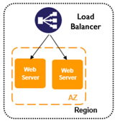

**Task 1: Launch web servers**

We go to services > EC2 > instances and launch the instances  
We enter the name MyLBInstances known as a tag and we build this lab on Amazon linux

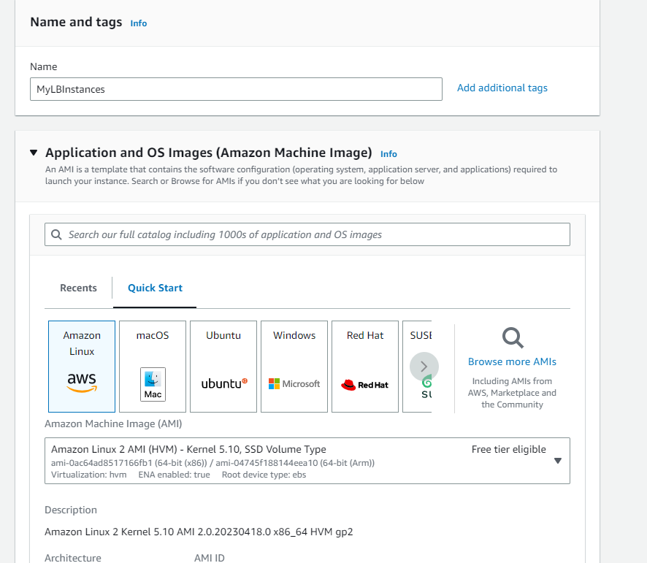

Select t2.micro because is the cheapest option and proceed without key pair

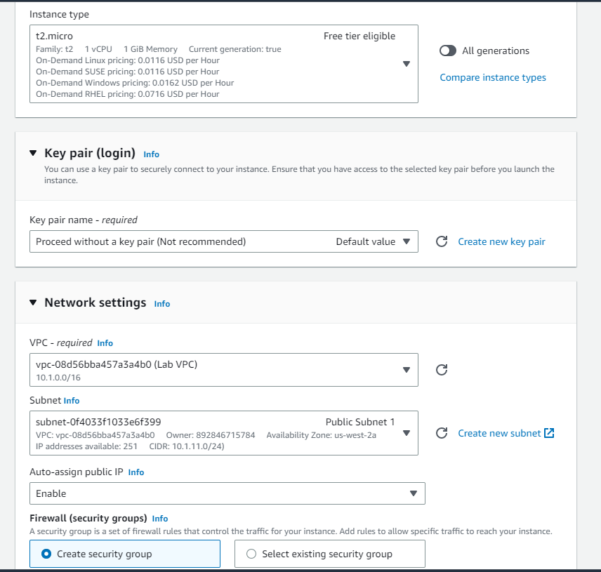

Create security group > remove the SSH existing security rule and add a new one with HTTP and the source type should be Anywhere

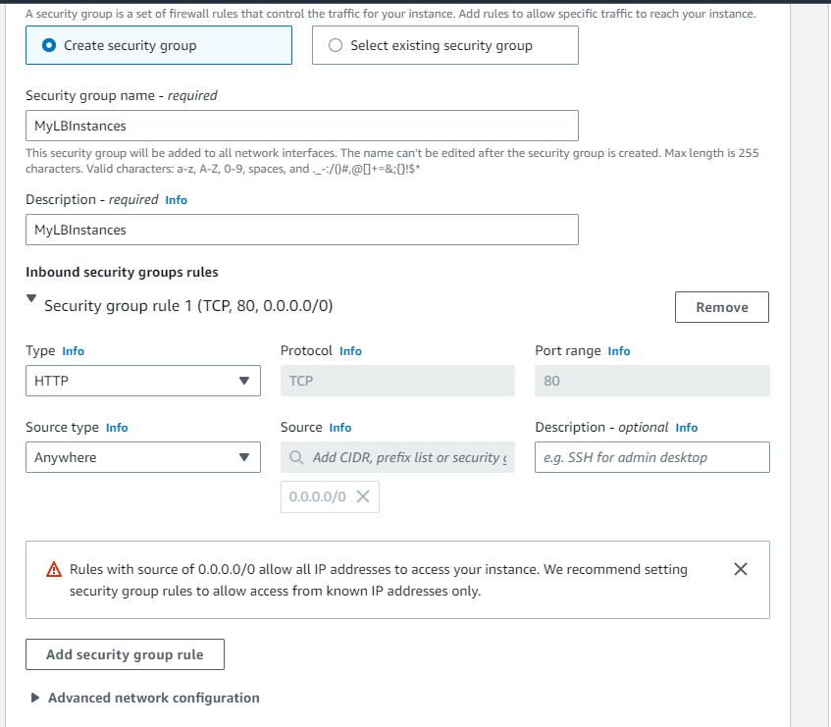

In the advanced details we add this user data that will allow to bootstrap the instance, it will install apache and PHP scripts that will be needed when the instance is created and launched.   
Also we are changing the number of instances to 2 since we want to create two instances.  
Launch the instance

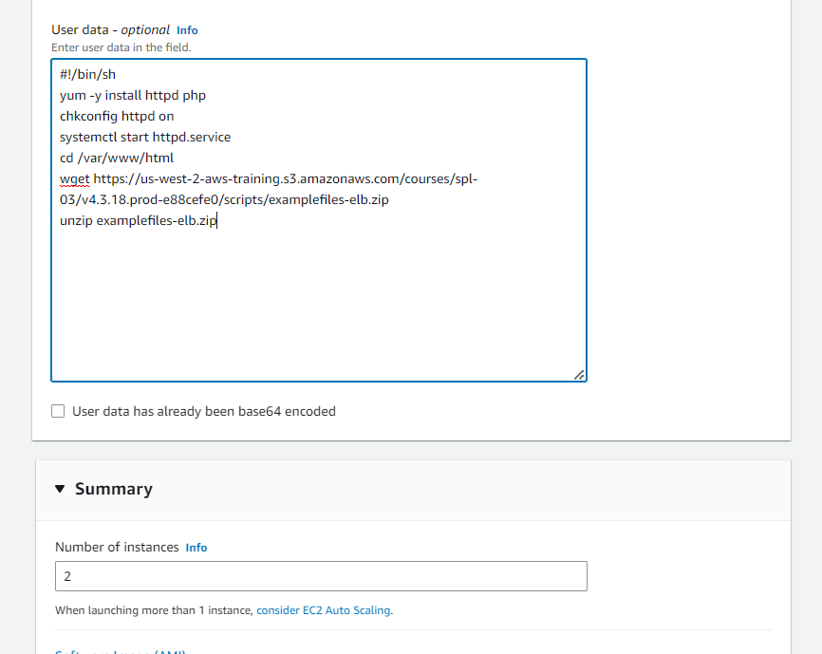

View all instances , they should be in running state 2/2 passed

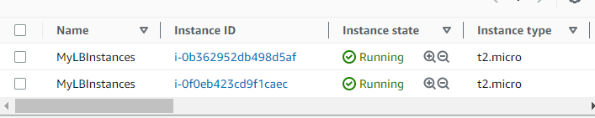

**Task 2: Connect to each web server**

We retrieve the public DNS from the two instances and open a new tab to check if the PHP script is installed and the instance is started  
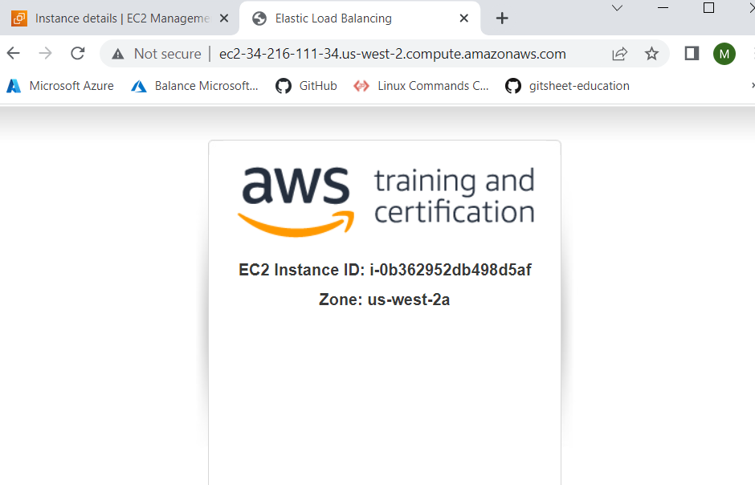

We repeat the same steps for the second instance

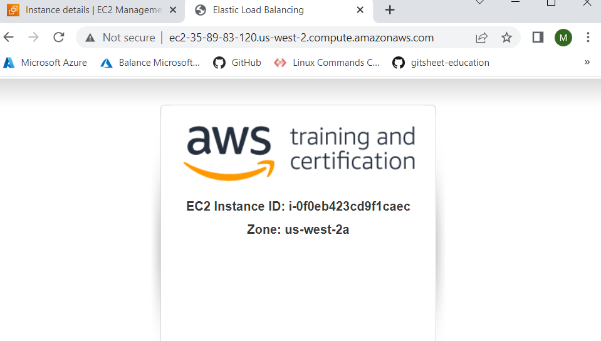

**Task 3: Create load balancer**

We have the two web servers and now we need a load balancer to give the users a single location for both of them

Go to load balancers> create > application load balancer > create and configure



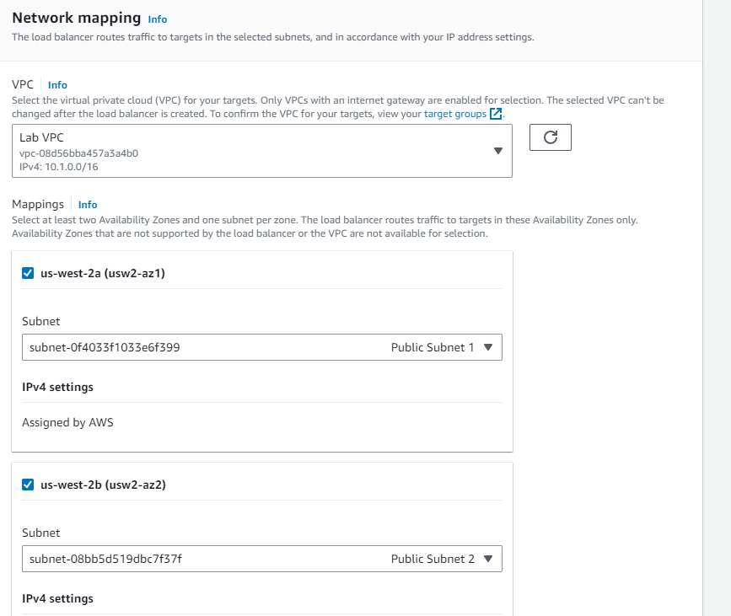

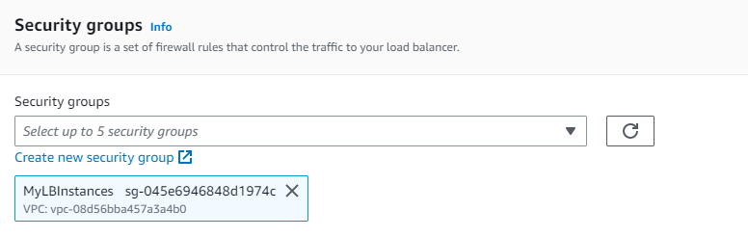

When we create new target group a new tab will pop up to configure the details

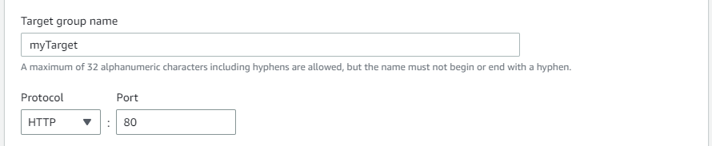

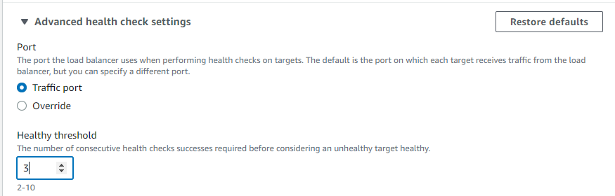

We need to select the two instances

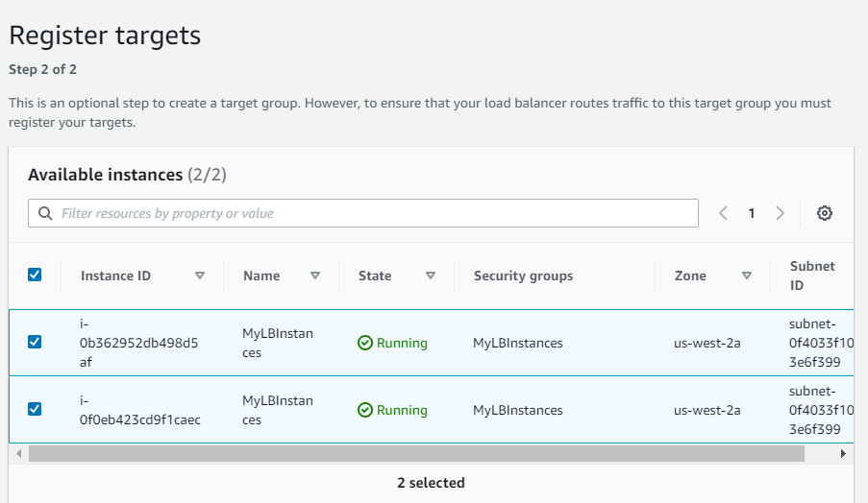

And create the target group

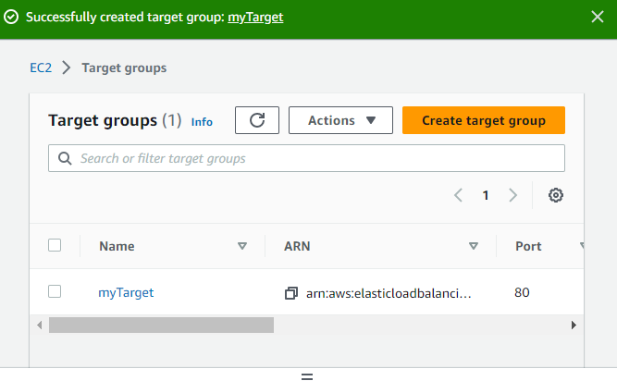

When we go back to the first tab and reload the new target group will appear in the drop down

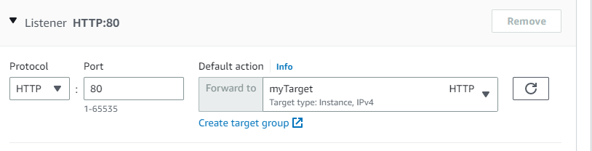

We click create load balancer

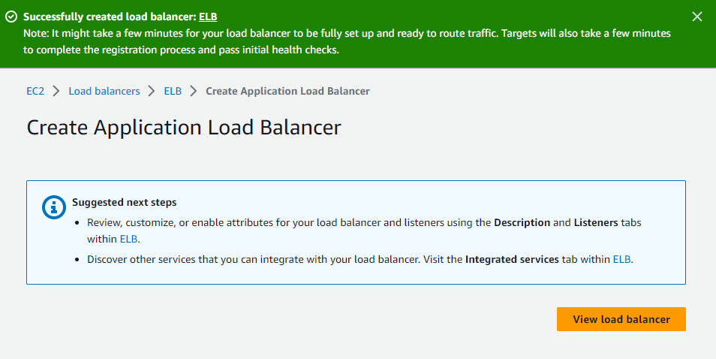

View load balancer and check if the state is active, next we grab the DNS name and open a new tab

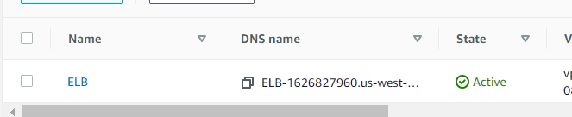

The new tab is supposed to look like this

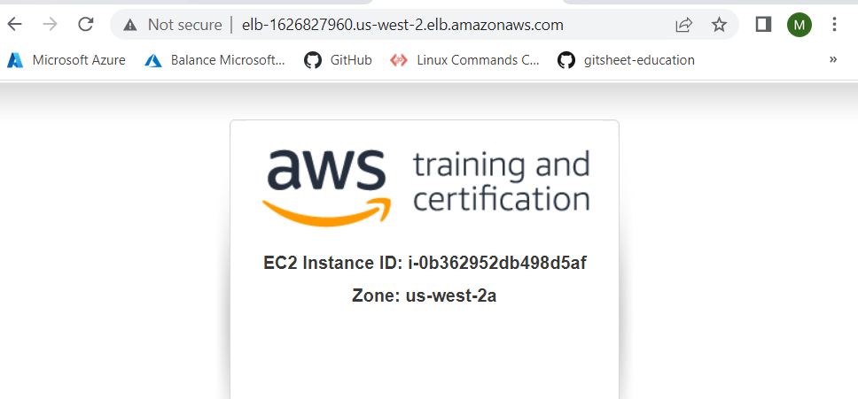

And every time we reload the ID of the instance will change because the responses are coming back through two different web servers



We can also check the targets tab and we can see that the instances are healthy 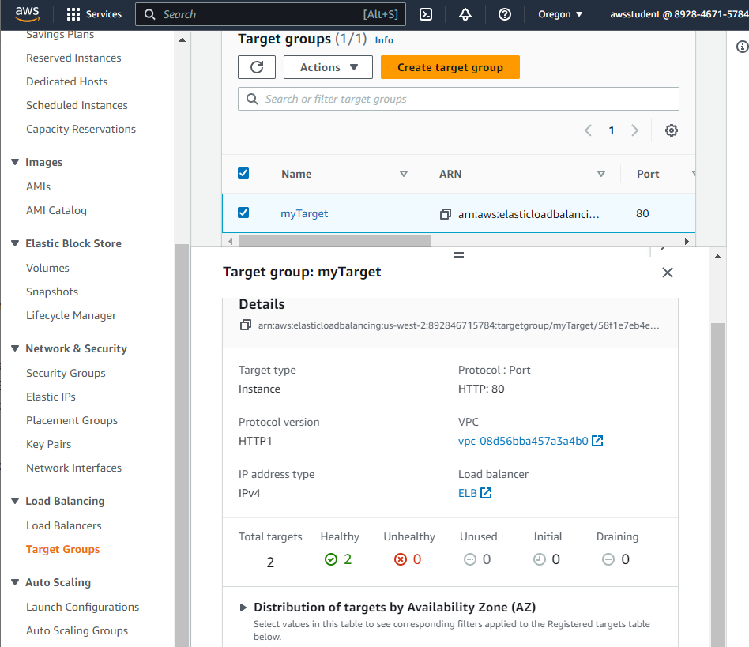

Task 4: View elastic load balancing cloudwatch metrics

We open Services > Cloudwatch > metrics

And we can check some of the metrics that will arear in few minutes  
Average CPU utilization

